Architecture Document
1. Selected Architecture: Modular Monolith
For the DockSec project, we have implemented a **Modular Monolithic Architecture**.
### 1.1 Detailed Explanation
A **Monolithic Architecture** is a unified model where all components of the application are interconnected and interdependent, rather than being loosely coupled as is the case with microservices. In DockSec, this means that the entire scanning logic, from image retrieval to report generation, resides within a single codebase and runs as a single process.
However, DockSec specifically employs a **Modular Monolith** approach. This means that while the application is a single deployment unit, its internal logic is strictly organized into independent modules (packages) with well-defined interfaces and responsibilities.

**Key Characteristics in DockSec:**
- **Single Process**: The scanner runs as a single Python execution.
- **Shared Data Structures**: Information about packages and vulnerabilities is passed between modules in memory.
- **Separation of Concerns**: Each step of the scanning process (OS detection, package extraction, etc.) is isolated in its own script within the `scanner/` directory.

### 1.2 Design Rationale

The choice of a Modular Monolith was driven by several factors:
1. **Simplicity & Speed**: For a CLI tool, a monolith eliminates the overhead of network communication and service discovery required by microservices.
2. **Deployment Ease**: Users only need to install a single package and its dependencies to start scanning images.
3. **Data Consistency**: Passing data in-memory ensures high performance and reduces the complexity of synchronization.
4. **Learning Path**: It provides a clear, understandable structure for students to learn the fundamentals of container security without being bogged down by distributed systems complexity.

---

## 2. Component Descriptions

| Component | Responsibility |
| :--- | :--- |
| **Main CLI (`main.py`)** | Orchestrates the entire scan process and handles user input. |
| **Image Loader** | Interfaces with the Docker Engine to check its status and pull target images. |
| **OS Detector** | Identifies the base OS (e.g., Alpine, Debian) to determine which package manager to query. |
| **Package Extractor** | Securely extracts installed package metadata from the image filesystem without executing it. |
| **CVE Matcher** | Compares extracted packages against a local vulnerability database. |
| **Risk Engine** | Evaluates the severity of findings and calculates an overall risk score. |
| **Reporter** | Formats findings into human-readable (Markdown) and machine-readable (JSON) reports. |

---

## 3. Security Model: Filesystem-Only Inspection

A critical architectural decision in DockSec is the **Secure Execution Model**. Unlike some scanners that might run a container to query its packages, DockSec uses a filesystem-only approach:
1. **Stopped State**: Containers are created but never started (`docker create`).
2. **Filesystem Export**: The container's filesystem is exported to a temporary tarball.
3. **Passive Parsing**: Metadata files like `/var/lib/dpkg/status` are read directly from the tarball.

This prevents the execution of malicious code that might be embedded in an untrusted Docker image.

Use Case Diagram
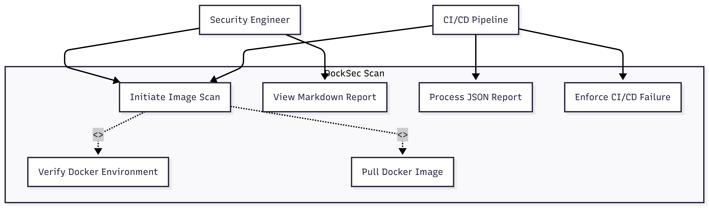
Class Diagram
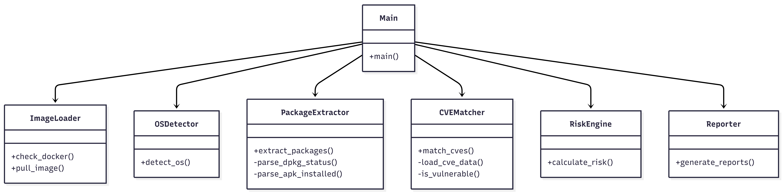

DFD
ER DIAGRAM
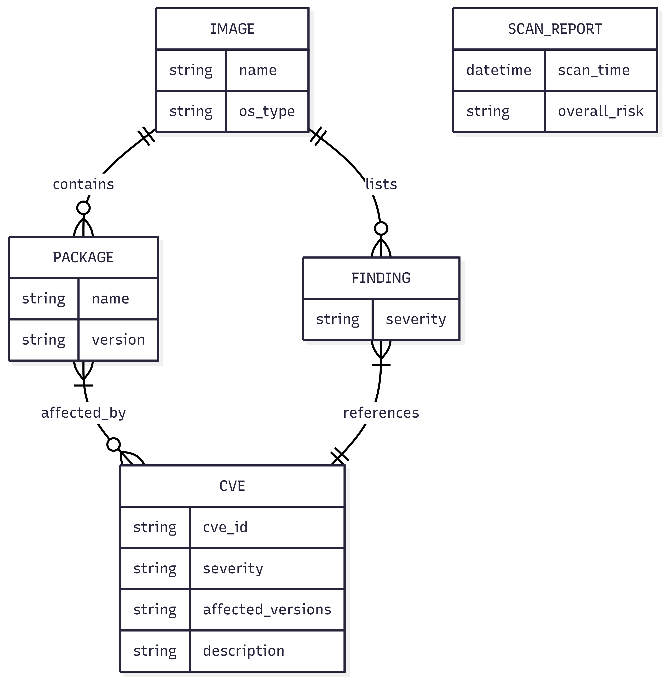

SCHEMA DIAGRAM
CVE Database Schema
Column Name | Data Type | Constraint | Description
cve_id | String | Primary Key / Unique | Unique identifier for the vulnerability (e.g., CVE-2024-1234)
severity | Enum | NOT NULL | Risk level: LOW, MEDIUM, HIGH, CRITICAL
packages | Array[String] | NOT NULL | List of package names affected by this CVE
affected_versions | String | NOT NULL | Version expression (e.g., "< 1.2.3", ">= 1.0.0, < 2.0.0")
description | String | Optional | Detailed explanation of the vulnerability and its impact
Scan Report Schema
Field Name | Data Type | Description
image | String | Name and tag of the scanned Docker image
os | String | Detected operating system (e.g., alpine, debian)
scan_time | DateTime | ISO 8601 timestamp when scan was executed
overall_risk | Enum | Highest severity found among all detected CVEs

Findings
Field Name | Data Type | Description
package | String | Name of the vulnerable package
version | String | Installed version of the package
cve_id | String | Matching CVE identifier
severity | Enum | Severity level of the CVE
description | String | Brief explanation of the vulnerability

3. Data Exchange Contract

This section defines how data is moved and processed within the DockSec environment.

### 3.1 Frequency of Data Exchanges
- **On-Demand**: Data exchange is triggered exclusively by user initiation (CLI command) or CI/CD pipeline triggers.
- **Single Execution**: Each scan is independent; no persistent data state is maintained between scans except for the local CVE database.

### 3.2 Data Sets
| Data Set | Description | Source | Destination |
| :--- | :--- | :--- | :--- |
| **Target Image** | Name/Tag of the scan target. | User Input | Image Loader |
| **Package Metadata** | List of names and versions. | Docker Filesystem | CVE Matcher |
| **CVE Definitions** | Vulnerability signatures. | Local JSON File | CVE Matcher |
| **Scan Findings** | List of identified vulnerabilities. | CVE Matcher | Reporter |
| **Final Reports** | JSON and Markdown files. | Reporter | Local Filesystem |

### 3.3 Mode of Exchanges
- **CLI Arguments**: Initial configuration (image name) is passed via command-line arguments.
- **Docker Engine API**: Communication with Docker via subprocess calls (`docker pull`, `docker export`).
- **Internal (In-memory)**: Data between Python modules is passed as native dictionaries and lists.
- **Filesystem**:
- **Input**: Reading the local `data/demo_cves.json`.
- **Intermediate**: Temporary tarballs created during extraction.
- **Output**: Reports written to the `reports/` directory.

